<Title>

<Author>

Diploma Thesis

Supervisor: Prof. <Name> <Surname>

Ioannina, <Month>, <Year>
Τμημα Μηχ. Η/Υ & Πληροφορικής
Πανεπιστήμιο Ιωαννίνων
Department of Computer Science & Engineering
University of Ioannina

Acknowledgments
Here you thank anyone you feel obliged to acknowledge. This Chapter is optional.

<Date>
<Author>

Abstract
Summary in English (up to 200 words)

Keywords: <keyword 1>, <keyword 2>

Περίληψη (extended abstract in Greek)
Επεκτεταμένη περίληψη στα ελληνικά (έως 2 σελίδες).

Λέξεις Κλειδιά: <Λέξη 1>, <Λέξη 2>

Table of Contents
Chapter 1. <Chapter Title> 7
1.1 <Section Title> 7
1.1.1 <Subsection title> 7
Chapter 2. <Chapter Title> 8
2.1 Examples of references 8
2.2 Example for Tables 8
2.3 Examples for Figures 9

<Chapter Title>

<Section Title>
The text of the section falls here.
As abroad advice: Typically, in technical writing we are careful to follow the structure <context><subject><verb><object><everything else>. We typically use the present tense and the first-person plural.
E.g., <In this Section,> <we><investigate><the problem of finding the shortest path in a directed graph><when the diameter of the graph is large and the average node centrality is small>.

<Subsection title>
Subsection text.

<Sub-subsection title>
Sub-subsection text.

<Chapter Title>

Examples of references
In [JJQV98], the authors describe an architecture …
/* ATTENTION: we never say “they describe”, but “the authors describe” */
Bernstein et al., [BBC+99] introduce a model for …
The theoretical analysis of the model in [Orr98a] demonstrates that …

Example for Tables
An example of a table of numbers is depicted in Table 2.1. It is not obligatory for you, but the choice made here was to depict the max value of each dataset in bold red and the respective minimum value in blue italics.
To describe a table, you can use a text a long these lines: “In Table 2.1 we depict/present/… the distribution of tables to activity classes for the 8 datasets of our experiments. The first column includes the name of the data set, the second column includes the total number of tables of the data set. Each of the subsequent three columns corresponds to one of the three activity classes and demonstrates the number of tables that pertain to it; similarly, for the last three columns containing the respective percentage of the total number of tables of the data set. We observe that …”.

Breakdown of Tables over their Activity Class
(Percentages over Total #Tables)
 |  | Activity Class |  |  | Activity Class (%)
Dataset | Total  #Tables | RIGID | QUIET | ACTIVE | RIGID | QUIET | ACTIVE
Atlas | 88 | 18 | 43 | 27 | 20% | 49% | 31%
BioSQL | 45 | 16 | 13 | 16 | 36% | 29% | 36%
Castor | 91 | 57 | 31 | 3 | 63% | 34% | 3%
SlashCode | 68 | 15 | 38 | 15 | 22% | 56% | 22%
Zabbix | 56 | 23 | 30 | 3 | 41% | 54% | 5%
Table 2.1ble 2.2 Distribution of relations in different classes of activity, both in absolute values and percentages

Examples for Figures
Similarly, we visualize results in bar-charts and timelines.
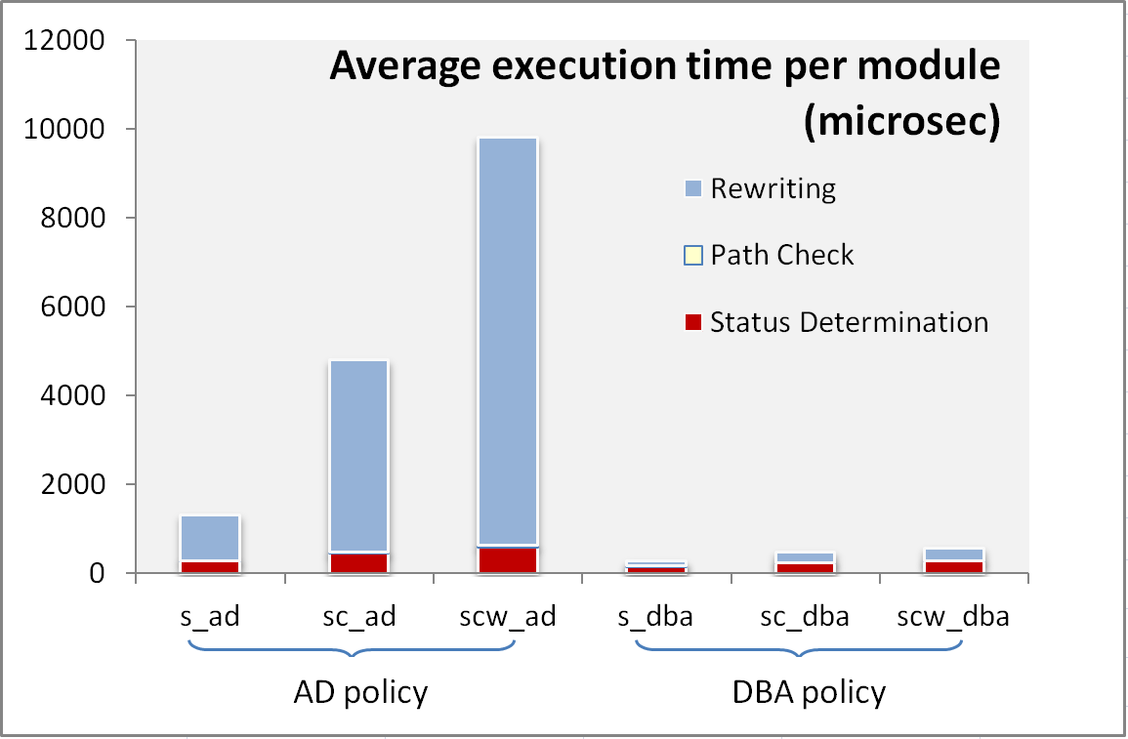
Figure 2.1 Breakdown of the average execution time (microsec) per database module and propagation policy (AD, DBA) for the three parts of the evolution propagation algorithm (rewriting, path check, status determination)

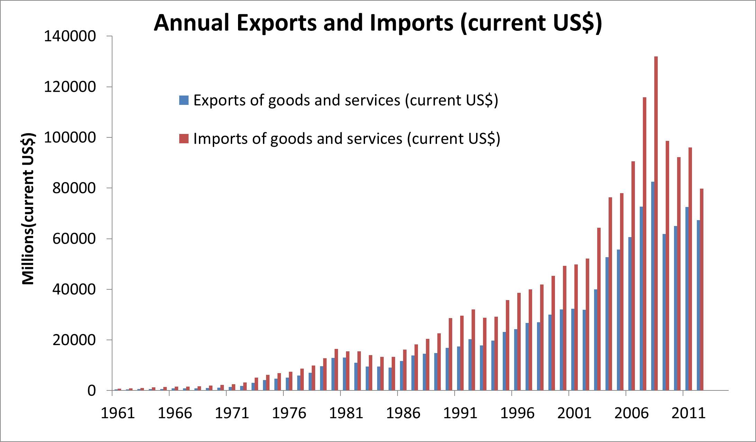
Figure 2.2 Evolution of exports and imports of goods and services for Greece, in millions of current US$ on an annual basis

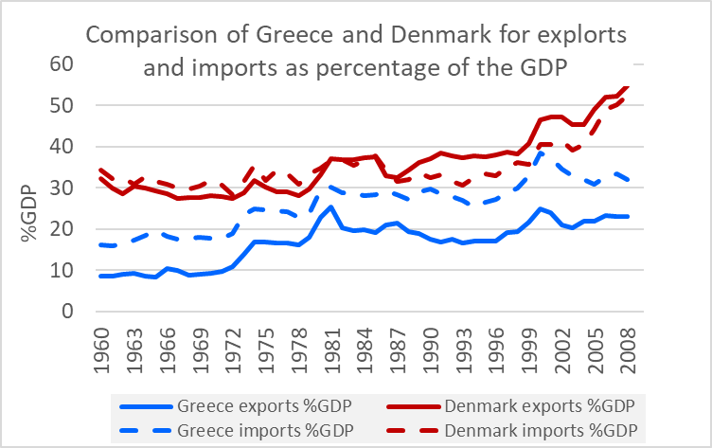
Figure 2.3 Comparison of (a) exports and imports, for (b) Greece and Denmark, as a percentage of their GDP, on an annual basis for the years 1960-2009.
A typical way to present results is by presenting first the axes and the data series within the chart, and then commenting on the observed phenomena. E.g.:
“In Figure 2.3 we depict a comparison of (a) exports and imports, for (b) Greece and Denmark, as a percentage of their GDP, on an annual basis for the years 1960-2009. Thus, we have for data series, for the combination of values for (A) and (b). The horizontal axis refers to time, on an annual basis, and the vertical axis measures the value of each data series as a percentage of the GDP. Observe that …. “

References
[BBC+99] | P.A. Bernstein, T. Bergstraesser, J. Carlson, S. Pal, P. Sanders, D. Shutt. Microsoft Repository Version 2 and the Open Information Model. Information Systems 24(2), pp. 71-98, 1999.
[BCR94] | V.R. Basili, G.Caldiera, H.D. Rombach. The Goal Question Metric Approach. Encyclopedia of Software Engineering, pp. 528-532, John Wiley & Sons, Inc, 1994. Also available at http://www.cs.umd.edu/users/basili/papers.html
[D97] | E.B. Dean. Quality Functional Deployment from the Perspective of Competitive Advantage. Available at http://mijuno.larc.nasa.gov/dfc/qfd.html
[JJQV98] | M. Jarke, M.A. Jeusfeld, C. Quix, P. Vassiliadis. Architecture and quality in data warehouses. In Proc. 10th Conference on Advanced Information Systems Engineering (CAiSE '98), pp. 93-113, Pisa, Italy, June 1998.
[JV97] | M. Jarke, Y. Vassiliou. Foundations of data warehouse quality – a review of the DWQ project. In Proc. 2nd Intl. Conference Information Quality (IQ-97), pp. 299-313, Cambridge, Mass., USA, June 1997.
[O98a] | K. Orr. Data quality and systems theory. In Communications of the ACM, 41(2), pp. 54-57, Feb. 1998.
[O98b] | K. Orr. Another paper in the same year. In Proc International Conference on Computer Science, 41(2), pp. 54-57, 1998.

