0. Configuration

(a) Create a folder **ParmenidianConfig** within the dataset you want to work with to host the configuration file + a a **ParmenidianOutput** folder to host the screenshots + pptx + mp4

(b) Create a workspace in the **ParmenidianConfig** folder

(c) Create a new project, with Project Name *myDataSetName*_PT

(d) Fill the details as follows:

- sql folder: the folder where you have the .sql

- transition file: transitions.xml within the results file (by Hecate)

- output folder: the **ParmenidianOutput** folder

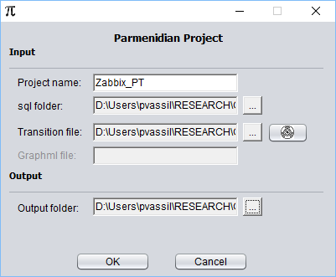

The result of this is that within the **ParmenidianConfig** folder you have a ***myDataSetName*_PT.ini** file

1. Then, the project opens && **you have to arrange the nodes** gracefully.

2. Then, you generate the screenshots _graphml,

- Screenshots reside in the **ParmenidianOutput/screenshots** folder.

- graphml resides in the INPUT folder ☹ & you have to (a) cut it and paste it into the **ParmenidianConfig** folder, and (b) edit the **ParmenidianConfig/xxxx.ini** and put the path for the graphml at the **ParmenidianConfig** folder.

3. Then you need to generate the pptx. You specify the **ParmenidianOutput/screenshots** folder as input and you get the pptx in the **ParmenidianOutput/** folder.

4. Then you generate the metrics. Click Run -> Generate Metrics (second) **and tick ALL the metrics** that you want.

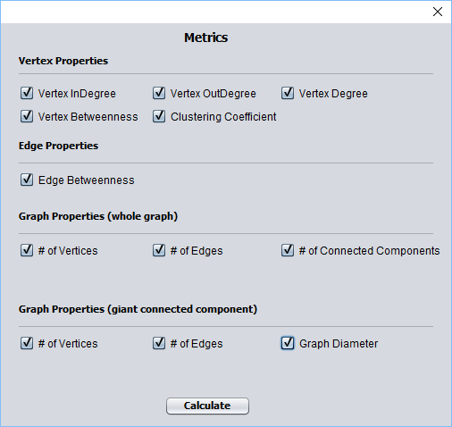

The metrics are produced as csv files in the **ParmenidianOutput/** folder.

5. Then, you can generate the video. You need to specify which pptx file you have as input (probably the one you have just generated at the **ParmenidianOutput/** folder). The results is stored in the folder **ParmenidianOutput/**. The process takes time; a way to know that it has finished is if the **ParmenidianOutput/** folder is cleaned-up from the temporary figure files extracted from the pptx.